## **Dual-Stack Lite (DS-Lite) Setup Guide**

**Dual-Stack Lite** technology does not involve allocating an IPV4 address to [customer-premises equipment](https://en.wikipedia.org/wiki/Customer-premises_equipment) (CPE) for providing Internet access. It is described in [RFC 6333](https://tools.ietf.org/html/rfc6333). The CPE distributes [private IPv4 addresses](https://en.wikipedia.org/wiki/Private_network) for the LAN clients, according to the networking requirement in the local area network. The CPE [encapsulates](https://en.wikipedia.org/wiki/IP_tunnel) IPv4 packets within IPv6 packets. The CPE uses its global IPv6 connection to deliver the packet to the ISP's [Carrier-grade NAT](https://en.wikipedia.org/wiki/Carrier-grade_NAT) (CGN), which has a global IPv4 address. The original IPv4 packet is recovered and NAT is performed upon the IPv4 packet and is routed to the public IPv4 Internet. The CGN uniquely identifies traffic flows by recording the CPE public IPv6 address, the private IPv4 address, and TCP or UDP port number as a session.

This Setup Guide is a simple document descriptive how to setup AFTR server on Ubuntu Linux.



Note: CPE means DUT in following topology.

# **Topology:**

# **Requirement:**

1. AFTR server:
   1. A recent PC with two Giga ethernet (additional giga ethernet must use PCIe base Lan card, PCI interface giga LAN card can only provide 400~500Mbps throughput), our PC have following two giga LAN (eth1 is PCIe)
      1. eth0 : Intel Giga 82579V
      2. eth1 : Intel Giga CT (82574L)
   2. OS: Ubuntu 14.04.3 LTS
2. DUT: Any router support DS-lite
3. Client:
   1. Any PC with windows 7 (support IPv4 and IPv6)
   2. PC must have one Giga ethernet (for ethernet test)
   3. A WiFi adapter (for WiFi test)
   4. Chariot console v6.7 (IPv6 support)

# **Setup AFTR server:**

1. Setup Network configure to enable IPv4/IPv6 forward
   1. edit /etc/sysctl.conf enable following two setting
      1. net.ipv4.ip_forward=1
      2. net.ipv6.conf.all.forwarding=1
   2. let the setting take effect immedially
      1. sudo sysctl -p
2. Setup ethernet configure
   1. edit network/interfaces eth0's setting to fit your environment
      1. nano network/interfaces
         1. update ipv4 address, netmask, gateway and dns-nameservers

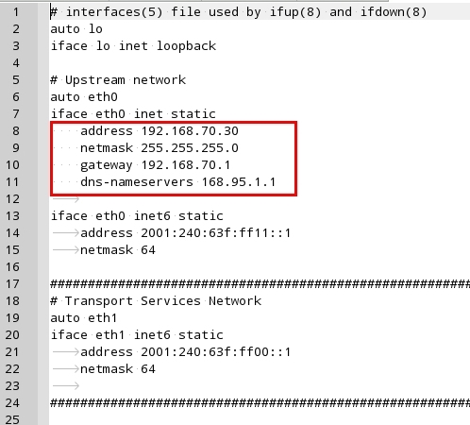

* 1. copy config file “interfaces” to /etc/network/
     1. sudo cp network/interfaces /etc/network/
  2. let config take effect
     1. Do not let network-manager to handle the ethernet
        1. sudo service networking stop
     2. restart ethernet
        1. sudo ifdown eth0
        2. sudo ifdown eth1
        3. sudo ifup eth0
        4. sudo ifup eth1
  3. Make sure eth0 can connect to internet (following setup need to get some ubuntu package from internet)

1. Setup DNS server ( Bind9 )
   1. Install Bind (Current Bind9 version is 1:9.9.5.dfsg-3ubuntu0.5)
      1. sudo apt-get install bind9
   2. Setup Bind
      1. sudo cp bind/named.conf /etc/bind/
      2. sudo cp bind/named.conf.example-zones /etc/bind/
      3. sudo cp bind/named.conf.logging /etc/bind/
      4. sudo cp bind/named.conf.options /etc/bind/
      5. modify bind/named.example to fit your environment

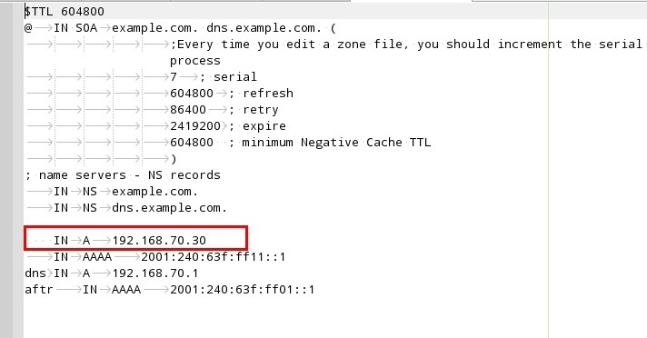

* + 1. sudo cp bind/named.example /etc/bind/
  1. Start DNS
     1. sudo service bind9 start

1. Setup IPv6 radvd
   1. Install radvd
      1. sudo apt-get install radvd
   2. Setup radvd
      1. sudo cp radvd.conf /etc/
   3. Start radvd
      1. sudo service radvd start
2. Setup dhcpv6
   1. Install dhcp server
      1. sudo apt-get install isc-dhcp-server
   2. Setup dhcpv6 server
      1. sudo cp dhcp/isc-dhcp6-server /etc/init.d/
      2. sudo cp dhcp/default/isc-dhcp6-server /etc/default
      3. sudo sudo mkdir /var/db/
      4. sudo touch /var/db/dhcpd6.leases
      5. modify dhcp/aftr-dhcpd6.conf with DUT's WAN Mac address

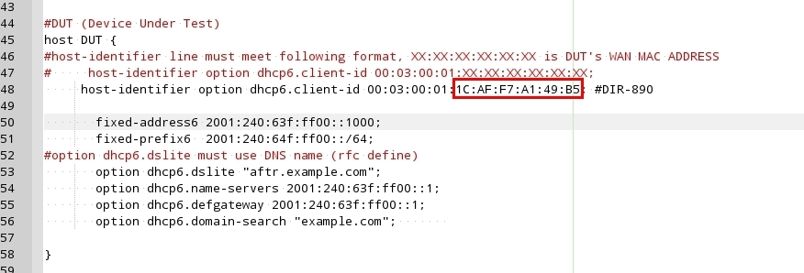

* + 1. sudo cp dhcp/aftr-dhcpd6.conf /etc/dhcp/
  1. Start dhcpv6 server
     1. sudo service isc-dhcp6-server start

1. Setup aftr
   1. Install aftr
      1. sudo apt-get install dpkg-dev
      2. cd source
      3. tar xvf aftr-1.1.tar.bz2
      4. cd aftr-1.1
      5. dpkg-buildpackage -b
      6. cd ..
      7. Install aftr by dpkg command (on x86 system replace file name to deb file create on step 5)
         1. sudo dpkg -i aftr_1.1-1_amd64.deb
   2. Setup aftr
      1. Modift aftr/aftr.conf pool address

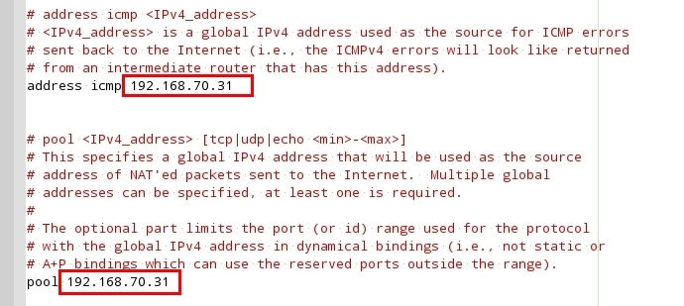

* + 1. sudo cp aftr/aftr.conf /etc/aftr/
    2. modify aftr/aftr-script pool address and fit to AFTER server's WAN (eth0) Mac address

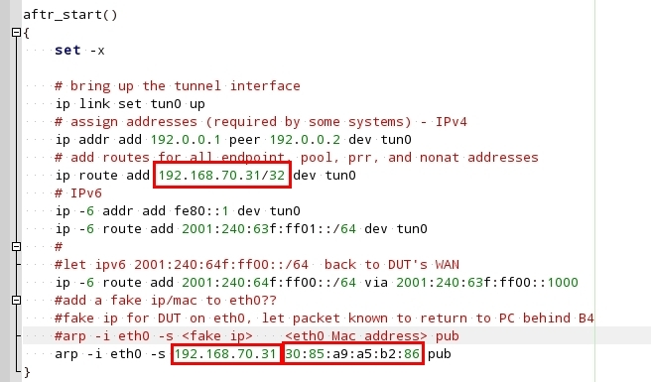

* + 1. sudo cp aftr/aftr-script /etc/aftr/
  1. Start aftr service
     1. sudo aftr -c /etc/aftr/aftr.conf -s /etc/aftr/aftr-script

# **Setup DUT :**

1. Internet setting:
   1. Setup IPv4 to “DS-Lite”
   2. Setup IPv6 to “Auto Configuration (SLAAC/DHCPv6)”
2. Connect DUT's WAN to AFTR's eth1
3. Reboot DUT and check the DUT had create interface “ip4ip6.WA” in console by following command
   1. ifconfig
4. At AFTR server it will also create a interface “tun0”, use following command in console to check the interface is up
   1. ifconfig

# **Setup Client:**

1. Set client ethernet/wireless to use DHCP and connect to DUT's LAN port or wireless.
2. Client should be able to ping AFTR's WAN IPv4/IPv6 address
   1. ping 192.168.70.30
   2. ping 2001:240:63f:ff11::1

**Chariot throughput test:**

1. AFTR server need install chariot endpoint
   1. dpkg -i endpoint_8-1_i386.deb or endpoint_8-1_amd64.deb
   2. After install endpoint it will run endpoint, but it will not run after AFTR system reboot, we need to do following command to let endpoint start automatic when AFTR server bootup every time.
      1. cd /etc/init.d/
      2. sudo ln -s /usr/local/Ixia/rc2exec.lnx endpoint
      3. cd /etc/rc2.d
      4. sudo ln -s ../init.d/endpoint S04endpoint
      5. repeat step3 and 4 in folder rc3.d rc4.d and rc5.d
      6. cd /etc/rc6.d
      7. sudo ln -s ../init.d/endpoint K01endpoint
2. On Client, run chariot console
   1. IPv4:
      1. LAN → WAN:
      2. endpoint1 : Client IPv4 address (192.168.0.x)
      3. endpoint2 : AFTR WAN IPv4 address (192.168.70.30)
      4. for WAN → LAN traffic, do not swap endpoint1 and endpoint2's address, but edit the script and swap SEND and RECEIVE

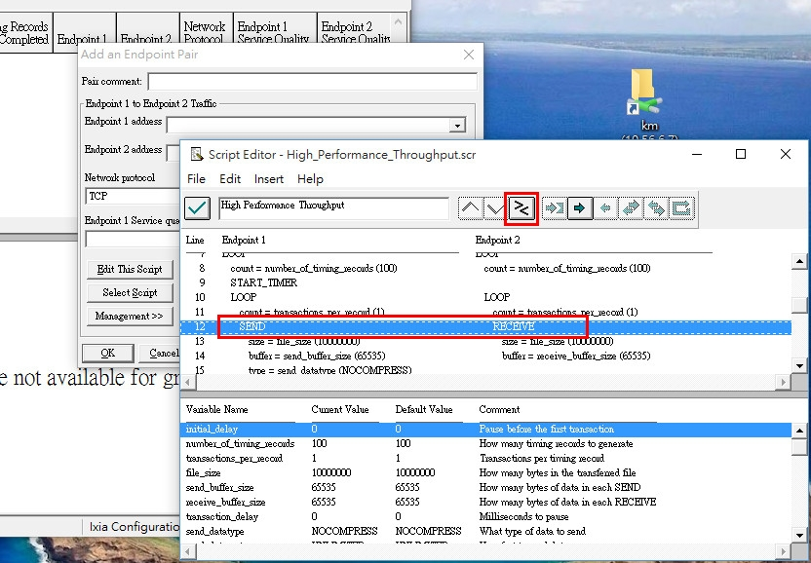

* 1. IPv6
     1. endpoint1 : Client IPv6 address (2001:240:64f:ff00::x)
     2. endpoint2 : AFTR WAN IPv6 address (2001:240:63f:ff11::1)

Remember before test any new DUT, change dhcp/aftr-dhcpd6.conf host-identifier's MAC address to fit DUT's WAN MAC address as in “**Setup AFTR server** V.B.5” description.

There is a script “00-start.sh”, it will help to start all the necessary service whenever you had change some setting. Run it in terminal as following (without >)

> sudo ./00-start.sh

## **References**

[RFC 6333](https://tools.ietf.org/html/rfc6333) - Dual-Stack Lite Broadband Deployments Following IPv4 Exhaustion

# Lightweight DS-Lite Setup Guide (<https://www.isc.org/downloads/lwds-lite/lwds-lite-setup-guide/>)

**History:**

|  |  |
| --- | --- |
| Version | Description |
| 2015.11.13 | First version |